**ASSIGNMENT – 24.4**

**Problem Statement:**

1. Write a hive query find the average age of male and female persons died in the titanic tragedy.

2. Write a hive query to find the number of people died and survived in each class.

**Input Data Set:**

You can download the data set from the below link:

<https://drive.google.com/file/d/0ByJLBTmJojjzNmV0dk1EMmwwQ1U/view?usp=drive_web>

**DATA SET DESCRIPTION:**

Column 1: PassengerId

Column 2: Survived (survived=0 & died=1)

Column 3: Pclass

Column 4: Name

Column 5: Sex

Column 6: Age

Column 7: SibSp

Column 8: Parch

Column 9: Ticket

Column 10: Fare

Column 11: Cabin

Column 12: Embarked

**Solution:**

**Problem statement 1:**

* Write a hive query find the average age of male and female persons died in the titanic tragedy.

**Output:**

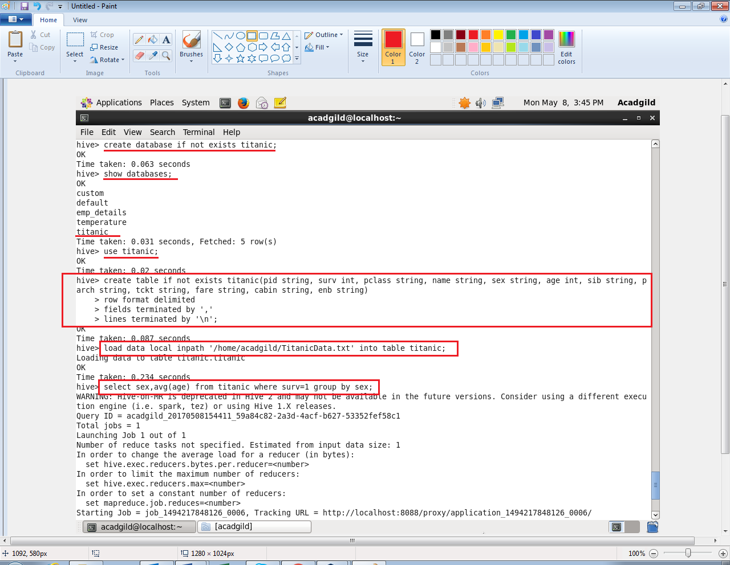

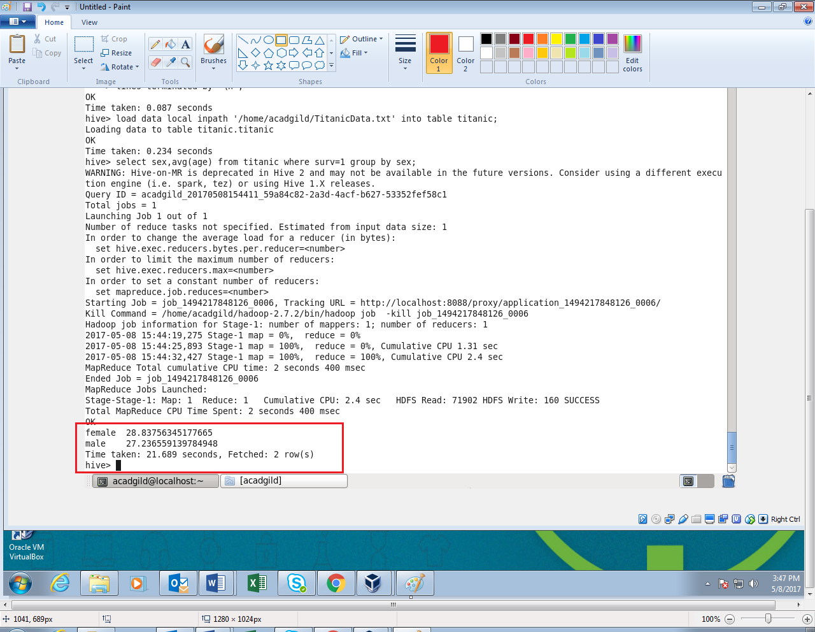

**Problem statement 2:**

* Write a hive query to find the number of people died and survived in each class.

**Output:**

